Summerfield Mailbox Guidelines
- An approved Change Request is required before work begins
- Be sure to speak with all neighbors sharing the stand
- All boxes and posts must be USPS approved
- For a special request, such as a large group mailbox often found at townhomes, speak with the USPS
- Box color must be black
- Post must be black metal; wood posts are not allowed
Some Mailbox Options
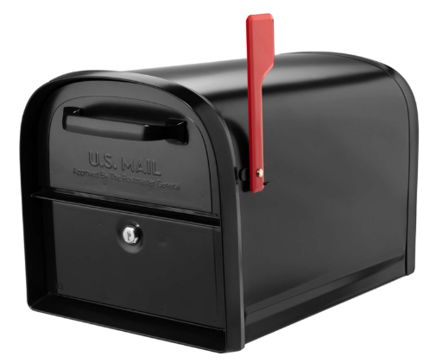
Architectural Mailboxes – available at Home Depot, etc.
Access with key from street AND sidewalk
Dimensions:
- Width: 11.3”
- Height: 11.5”
- Length: 20”
- Weight: 15.8 pounds

COGO (Columbia Gorge) Mailbox from Mailbox Solutions – a local mailbox installation company with special pricing for Summerfield.
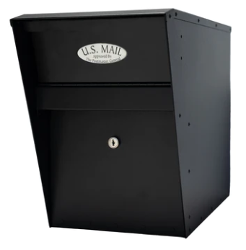
Dimensions:
- Width: 10.375” (10.625” with flag)
- Height: 15”
- Length: 21”
- Slot: 10” wide x 3.5” high
- Weight: 29 pounds

If you find a similar design, mailboxes and post must be USPS approved and approved by the Summerfield Architecture & Landscape committee.

